Regulations:
A14

H.T No

Sreenidhi Institute of Science and Technology
(An Autonomous Institution)
Code No: 4B616 Date: 03-Dec-2018 (AN)

B.Tech III-Year II-Semester External Examination, Nov/Dec - 2018 (Supplementary)
Principle of Finite Element Method (ME)

Time: 3 Hours Max.Marks:70

Note: a) No additional answer sheets will be provided.
b) All sub-parts of a question must be answered at one place only, otherwise it will not be valued.
c) Missing data can be assumed suitably.

Part - A Max.Marks:20

Answer all QUESTIONS.

1. | What is meant by discretization? | [2M]
2. | What are the boundary conditions in a truss problem? | [2M]
3. | What is the difference between constant strain triangular and linear strain triangular element? | [2M]
4. | What is meant by jacobian matrix? | [2M]
5. | How do you incorporated internal heat generation in finite element analysis of thermal problem? | [2M]
6. | What is the difference between eigen value problem and boundary value problem? | [2M]
7. | List different weighted residual methods. | [2M]
8. | What are the shape functions for a two noded beam element? | [2M]
9. | What is meant by plane strain analysis? | [2M]
10. | Distinguish between consistent and lumped mass systems. | [2M]
Part – B Max.Marks:50
ANSWER ANY FIVE QUESTIONS. EACH QUESTION CARRIES 10 MARKS.

11. |  | The thin plate of uniform thickness 20 mm, is as shown in Fig.. In addition to the self weight, the plate is subjected to a point load of 400N at mid-depth. The Young's modulus E = 2 × 10⁵ N/mm² and unit weight ρ = 0.8 × 10−4 N/mm². Analyse the plate after modeling it with two elements and find the stresses in each element. Determine the support reactions also.  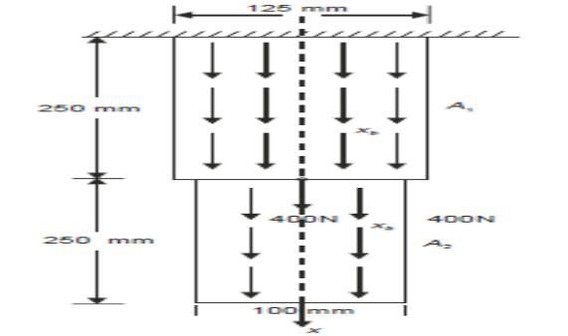 | [10M]
12. |  | Derive the transformation matrix for a plane truss element. | [10M]
13. | a) | Derive the stiffness matrix for the Constant strain triangular element. | [5M]
 | b) | For the CST element shown in Figure, determine strain–displacement matrix. Take, t = 20 mm, E = 2 × 10⁵ N/mm².  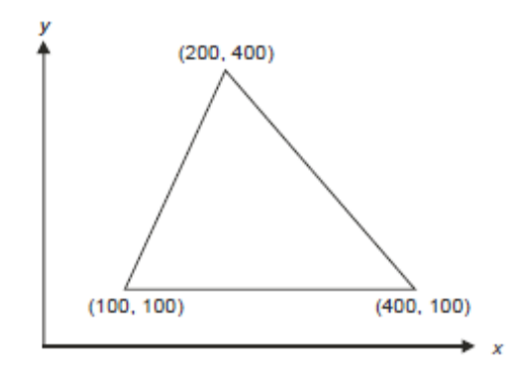 | [5M]
14. | a) | Derive the shape functions for a four noded quadrilateral element in natural coordinate system. | [5M]
 | b) | Derive the Gaussian points and corresponding weights for two point Gaussian quadrature approach | [5M]
15. |  | A composite wall consists of three materials as shown. The outer temperature is T₀ = 20 ⁰C. Convection heat transfer takes place on the inner surface of the wall with T∞ = 800 ⁰C and h = 25 W / m² ⁰C. Determine the temperature distribution in the wall.  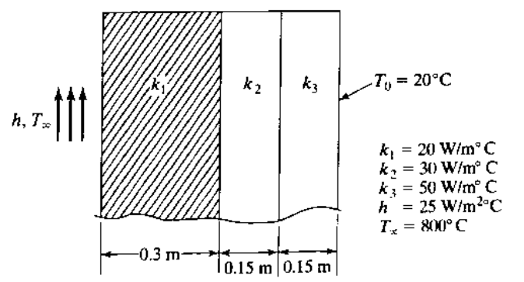 | [10M]
16. |  | Find the natural frequencies of longitudinal vibrations of the unconstrained stepped shaft of areas A and 2A and of equal lengths (L) | [10M]
17. |  | Derive K matrix for beam element | [10M]
18. |  | Derive shape function for two dimensional steady state heat conduction by triangular element | [10M]

-- 00 -- 00 –

